A Framework for Supporting e-Learning with Intelligent Features

Abstract
In part 1, we presented an adaptive e-Learning model that utilized different information systems for different e-Learning functionalities (El-Ghareeb, Riad, El-Minir, 2010). In this paper, intelligent techniques are presented to empower the proposed Adaptive e-Learning Model. This paper presents nine intelligent services that can be utilized in different e-Learning functionalities. These intelligent services are grouped into three categories based on their aims: General Services, Instructor Services and Student Services.
The General Services category includes the Intelligent Learning Object (LO) Classifier service. The Instructor Intelligent Services are: Intelligent Time-to-Learn Topic Calculator, Intelligent Study Plan Advisor, Intelligent Online Lecture LOs Advisor, Intelligent Student Performance Tracker and Intelligent Cheating Depressor. The Student Intelligent Services are: Intelligent Agenda Study Time Planner, Intelligent Meeting Manager for Suspended Students and Intelligent LOs Recommender.
Intelligent Online Lecture LOs Advisor enables what is called Adaptive Online Lecture Model that presents different pedagogical aspects via:
- Recommending the most suitable learning materials for students based on their learning profiles and preferences.
- Involving students in the learning process from the very early beginning of the lecture.
- Preparing for the next/upcoming lecture, so that students would feel the personalization and customization of the lecture.
Keywords: Adaptive Online Lecture, Intelligent e-Learning Framework, Student Profiles, Group Learning, Intelligent Recommender, Supervised e-Learning.

Introduction
Depending on the type of learning provided in the educational institution, different scenarios for utilizing intelligent techniques can be presented. Adaptive and intelligent Curriculum sequencing for example has been widely discussed in research, and presented in some cases. In addition to the fact that group learning is a necessity, personalized learning paths have been under research for a while. However, there were always doubts in the students’ capabilities and abilities to identify their learning paths, and doubts were always raised in intelligent systems capability to identify personalized learning paths without the need for instructors to fine tune the learning process.
Our proposed model shed lights on supporting e-Learning with intelligent features. One of the main features supported by our framework is supervised intelligent curriculum sequencing to present adaptive e-Learning fine-tuned by the instructor. Figure 1 presents the three proposed intelligent services’ categories. Characteristics of our proposed blended e-Learning model are:
- Students are grouped. Each group is delimited by the same start date. Students that do not catch this start date, are delayed to the next group, which is 15 days later.
- Learning goals are identified by instructors. Based on these learning goals, instructors define learning paths. Instructors can make use of the proposed Intelligent Study Plan Advisor Service. In this phase, intelligent service is only advisory for the instructor.
- Intelligent Time-to-Learn Topic Calculator is the service that is used to advise the instructor about the time needed for this group of students to study a certain topic. Based on this group of students study time of previous topics and the available LOs for this topic, this service can intelligently advise the instructor about the study time issue.
- Students attend one or more adaptive online lecture within the same learning goal. Adaptive online lecture makes use of the intelligent online lecture LOs advisor to recommend LOs for the instructor to use during the lecture, based on the students’ learning profiles.
- Intelligent LOs Recommender is the intelligent service that will recommend LOs for students based on their learning profiles. Recommended LOs list is approved by the instructor. Then, Recommended LOs list is reordered based on the students’ preferences.
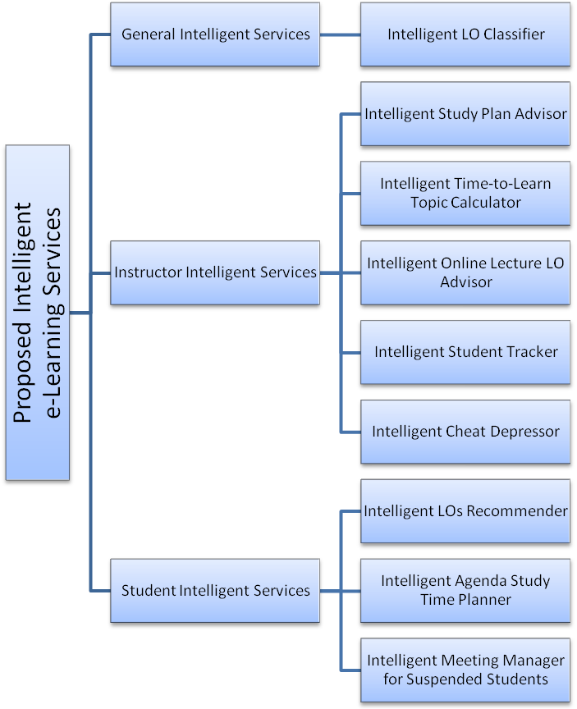
Figure 1: Different Proposed Intelligent e-Learning Services
- Intelligent Agenda Study Time Planner is used to organize the students’ time tables and organize their different activities.
- Intelligent Student Tracker service is used to track the students’ performances during the online learning journey. Peaks and performance degradation in students’ performances need to be recorded and studied.
- Learning path is marked by different learning checkpoints. At each checkpoint, students attend an online exam. Those who pass will continue the learning path. Those who fail will have to re-attend the exam within 4 days. If they fail again, they will have to re-attend the exam within 2 days. If they do not pass the third time, they are suspended.
- Intelligent Meeting Manager for Suspended Students service is responsible for managing a meeting between an instructor and the suspended student to handle the learning issues that prevent this student from coping with her/his group. Suspended students drop behind their group.
- Intelligent Cheat Depressor service focuses on utilizing intelligent techniques in prohibiting students from cheating. When combining both Intelligent Student Tracking service, and Intelligent Cheat Depressor service, combined with forecasting of students’ scores in the coming exams, cheating can be identified. Different cheating prohibition mechanisms are presented in this paper.

General Intelligent Services
This category includes services that can be utilized by both instructors and students. Based on the recent analysis of our proposed Adaptive e-Learning Model, this category includes the Intelligent LO Classifier.
Different intelligent techniques can be utilized in classifying LO based on LO type. Classifying multimedia-based LOs can be easy via meta-data access, while classifying text-based LOs can be done via accessing its content. Different standards for LOs metadata are available, however the most widely accepted standard is SCORM (Rosen, 2009). SCORM 2004 4th edition is the latest SCORM standard specification, issued in June 2008 (ADL Press Release).
Text classification or categorization is the process of organizing information logically. It can be used in many fields such as document retrieval, routing and clustering (Zhang, Kang, Silvescu , Honavar,, 2006). Document classification tasks can be divided into two sorts: supervised document classification where some external mechanism - such as human feedback - provides information on the correct classification for documents. The second sort is unsupervised document classification, where the classification must be done entirely without reference to external information (MOLE, 1999).
There is also a semi-supervised document classification, where parts of the documents are labeled by the external mechanism. Figure 2 presents Intelligent Document Classifier Class Diagram. Presented document classifier implements two of the Supervised Document Classification algorithms: Naive Bayes Classifier, and Term Frequency-Inverse Document Frequency (TF-IDF).
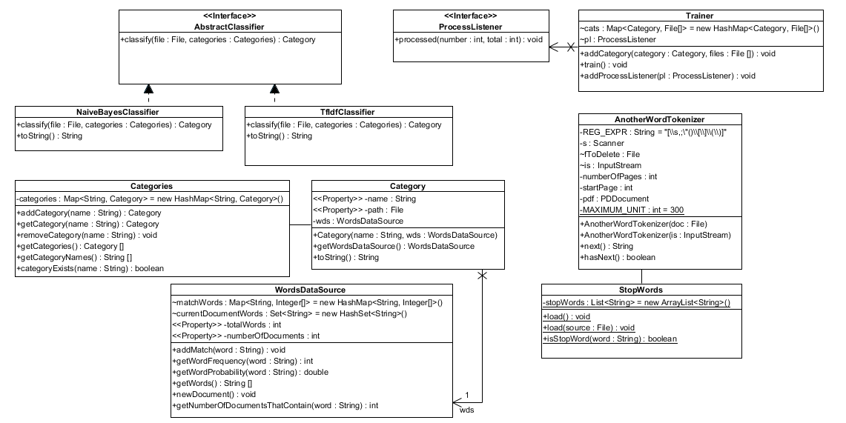
Figure 2: Document Classifier Class Diagram

Instructor Intelligent Services
The intelligent services that aimed to help the instructor through teaching are: Intelligent Study Plan Advisor, Intelligent Time-to-Learn Topic Calculator, Intelligent Online Lecture LOs Advisor, Intelligent Student Performance Tracker and Intelligent Cheating Depressor.

Intelligent Study Plan Advisor
Intelligent Study Plan Advisor is an intelligent advisory service used by the instructor to help her/him identify points of strengths and weaknesses in older study plans, and to identify different study plans for older groups, so they can be used in recommending a study plan for the current group.
Students differ in their learning behavior and learning preferences. The Intelligent Study Plan Advisor service considers different students as classes based on their learning preferences. Intelligent Study Plan Advisor service can be used in enhancing the LOs repository content by being able to identify the learning topics that do not have efficient LOs for different student classes. Table 1 presents the Intelligent Study Plan Advisor specifications, and figure 3 presents the detailed flow chart.
Table 1: Intelligent Study Plan Advisor Service Specifications
Input
Student Preferences | Proposed Model stores different learning preferences that identify student learning behavior. Those preferences are considered for identifying different study plans.
Learning Class | Students are grouped into Classes to ease educational tasks. Classes include: Auditory, Visual, and other classes that are discussed in detail in Learning Profile section.
Related LOs Specifications | LOs satisfy students’ classes by percentage. The higher LOs available that matches students’ preferences, the higher recommended this topic for teaching.
Study Plans for Previous Students | Instructor might need to take a closer look on previous instructor plans, grades that students scored by following certain plans, and other data.
Processing
By assigning different weights to the different inputs, intelligent methods can be used to generate a weighted list summary report.
Output
Summary Report | Recommended study plan for current study group.

Intelligent Time-to-Learn Topic Calculator
Intelligent Time to Learn Topic Calculator is an intelligent service that provides an important adaptive feature to the proposed model. Each topic is the summation of LOs for this topic. The instructors define the learning time for each LO. The system can identify the learning time variances between instructors identified learning time and the students consumed learning time. This time shift for current students and for elder group students is used in helping the instructor identifying the time required for students to learn some topics. This time can help the instructor during planning the course. Table 2 presents the Intelligent Time to Learn Topic Calculator specifications and figure 4 depicts a detailed flow chart.
Table 2: Intelligent Study Plan Advisor Service Specifications
Input
Instructor Defined Learning Time | LO’s author defines learning time for each LO. Later, different instructors can identify learning times for the same LO to match students’ skills.
Student Learning Time Shift | Tracking the student’s learning progress helped the system to calculate the time-to-learn shift between the defined time and the student actual time to learn. Average time to learn calculator will be presented.
Previous Groups Time To Learn Topic | Older groups’ time to learn the same topic is used as an input in the calculation process.
Processing
By assigning different Weights to the different inputs, intelligent methods can be used to generate a weighted list summary report.
Output
Time To Learn Topic | Time estimation for current group to learn certain topic.

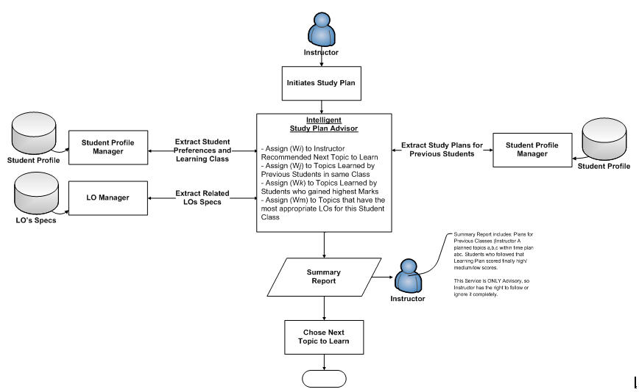
Figure 3: Intelligent Study Plan Advisor Flowchart
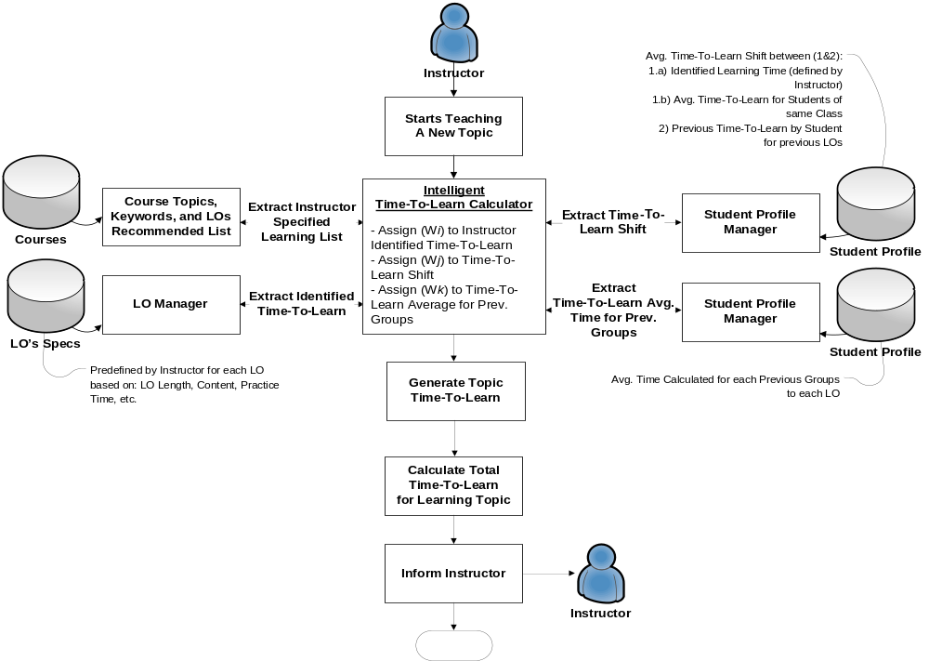
Figure 4: Intelligent Time-to-Learn Topic Calculator Flowchart

Intelligent Online Lecture LOs Advisor
The need for conducting and attending lectures in learning is clear for both students and instructors. It can be managed efficiently when they both exist in the same place and at the same time. The situation differs when students and instructors are experiencing either time and/or place differences/distances. Here comes e-Learning as the solution. Online meetings present the required audio and video communications between the instructor and students side by side, with the capability to share presentations, desktop activities and transfer files.
Different Online Meetings software and applications in both Web and desktop forms are available. However, their design and implementation was not aimed to be used for online lectures in the first place. Despite the tremendous advancement in technology that is witnessed by those applications, they still lack certain level of feedback from students to instructors that pushes students into more engagement within the learning process.
Intelligent Online Lecture LOs Advisor accesses students’ profiles and learning preferences side by side with data from previous online lectures and course specification data. This service provides the instructor with a recommended list of LOs based on the attending students. This list can be used during the lecture. Table 3 presents Intelligent Online Lecture LOs Advisor specifications, and figure 5 presents its detailed flowchart.
Table 3: Intelligent Adaptive Online Lecture LOs Advisor Specifications
Input
Student Preferences | Proposed Model stores different learning preferences that identify the student learning behavior. Those preferences are considered for identifying different study plans.
Related LOs Specifications | LOs satisfy students’ classes by percentage. The higher available LOs that match students’ preferences, the higher this topic is recommended for teaching.
Learning Topics Data | Proposed Model stores data about courses and topics to be pedagogically used in learning scenarios.
Previous Online Lectures Data | LOs that were used by previous instructors during online lectures for the same topic, and students’ feedback for those LOs are important data for this recommendation process.
Processing
By assigning different Weights to the different inputs, intelligent methods can be used to generate a weighted list summary report.
Output
Summary Report | Instructor can use this report to identify strength and weakness points of utilizing certain Los.
Engaging students in the lecture activities will enhance the students’ learning experience. Technically, this is available via extensive utilization of technologies that exist nowadays. During the online lecture, students are encouraged to give continuous informal feedback about different lecture activities via the same Web 2.0 technologies they are using. This feedback can be studied and analyzed later by the instructor. It can be used as an indicator on how the lecture was progressing, and know how to enhance the upcoming lectures.
Formal feedback request can be initiated by the instructor periodically to test certain points about which the instructor needs to ensure as a “check point” before moving on to the next point. Involving students in different assignments and activities during the lecture is welcomed and needs to be recorded in the students learning profiles.
Finally, preparing for the next lecture is not only the instructor’s responsibility. Pedagogically, the instructor is supposed to define the topics for the next lecture and the pre-requisites to learn these topics. Technically, Learning Management System (LMS) is supposed to check the student’s learning profile and preferences to define to what extent the student is familiar with those topics, and then providing the student with the learning materials. It is the responsibility of the student to study and examine these learning materials before the next lecture.

Phase One: Preparing the Lecture
The students' learning models are not the same, and that will be considered while selecting the contents to be displayed during the Online Lecture. In order not to lose the student’s attention during the lecture, types of contents shall be mapped with both their direct feedback and learning profiles. Figure 6 presents the different activities required to fulfill this process.
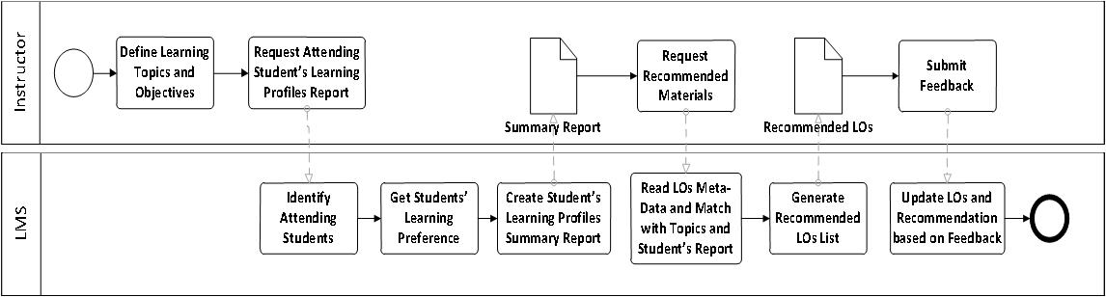
Figure 5: Recommend LOs for Instructor based on Analysis of Learning Profiles Process

Phase Two: During Online Lecture
The Proposed Adaptive Online Lecture Model attempts to address different lecture aspects that are not available in the current Video Conference Model. Those aspects are: Order of Contents, Assessments and Assignments & Collaborative activities.
- Order of Contents: Displaying the video file before / after discussing it or even twice in the lecture is one of the decisions that the instructor might not pay enough attention to, while it is important in keeping the students focused on the lecture activities. If the students are given some capability to re-order the contents of the lecture and discussions, they would feel the personalization of the Online Lecture, and would get deeply involved in the lecture.
- Assessments: Instructors might need to conduct one of the on the fly assessments to ensure that students have reached a basic level of knowledge regarding one of the topics they were discussing before moving on to the next topic.
- Assignments and Collaboration: Students attending the online lectures are already connected to the Internet via their laptops, they have accounts on multiple Web 2.0 collaboration tools providers, like Microsoft and Google, so they can easily transform to those tools based on the instructor’s directions. Their collaborative work can be marked and discussed online as if they are in a traditional lecture.
Figure 7 presents the proposed Activity Diagram of the During Lecture activities that will allow students to submit informal feedback during the lecture.

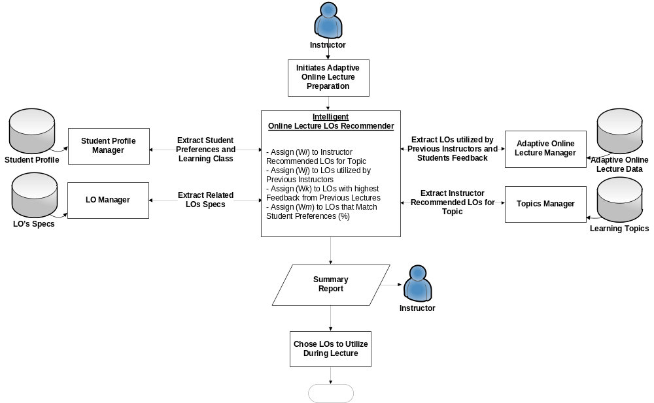Figure 6: Intelligent Online Lecture LOs Advisor Flowchart
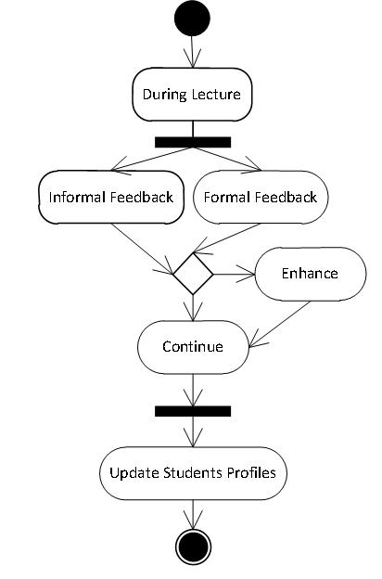
Figure 7: Formal and Informal Feedback Processes Synchronization during Lecture

Phase Three: Upcoming Lecture
One of the proposed Online Lecture Model activities is to identify the Next Lecture Topics based on the Students' Learning Profiles and Feedback. Before the students leave the current lecture, the instructor shall ensure that they are familiar with the prerequisites of the upcoming lecture. Proposed Adaptive Online Lecture can facilitate this by conducting assessments for the students and ask them clearly about the prerequisites.
Proposed Adaptive Online Lecture Model can access the Student Profile and Online Preferences for data about their previous attended sessions, courses, specifications and other details. In case one of the students does not satisfy the requirements defined by instructor, a personalized content can be generated for that student via Intelligent LOs Recommender, and then the student's interaction with those materials is tracked. Figure 8 presents the different system activities to support the adaptive LOs recommendation.
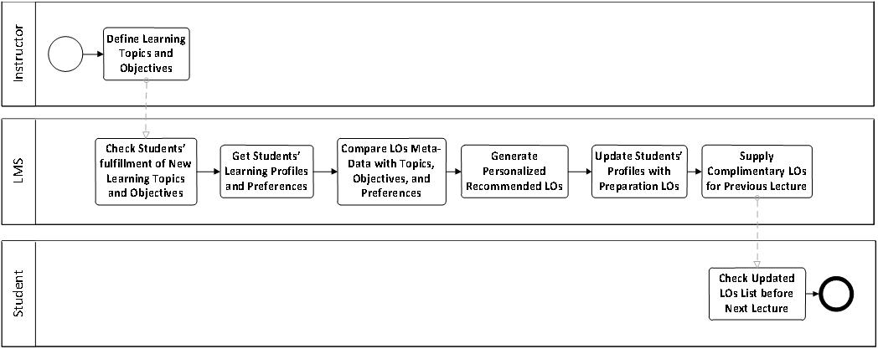
Figure 8: Recommend LOs for Students based on Upcoming Lecture Topics and their Preferences
Figure 9 presents a proposed IT architecture to support the proposed Online Lecture Model. Educational institutions differentiate between different components required to support the learning process, and are familiar with some technologies like UMIS and LMS. IT Architecture includes the following list of servers:
- Firewall: The system’s entry point, and responsible for providing security functions.
- Active Directory (LDAP): A Single Log-in point for the entire system. It helps avoid the repeated Log-in process between different applications and servers.
- Collaboration, Assessments and Assignments: Main components of the Learning Process that are maintained separately to provide greater flexibility and the ability to utilize different technologies.
- Students Data, Student Preferences and Learning Profiles: Main asset of LMS that maintains the students’ data to be utilized by different applications. Online Lecture Model relies heavily on those data to present personalized recommendations.
- Course Specifications and Instructors Data: Data about Instructors and Courses are stored to enable automating the communications between Course Management Systems (CMSs) and Recommenders.
- Real-Time Communication Server: Responsible for providing communications functionalities between instructors and students, and the students and each other. It manages Online Lecture file, desktop, text sharing, other activities and Web 2.0 technologies that will be used in the Informal Feedback.
- Analyzer and Report Generator: Responsible for analyzing gathered data and generating appropriate reports to help instructors take the appropriate decisions.
- Middleware: Responsible for managing Quality of Service (QoS) and directing messages among different components of the systems.
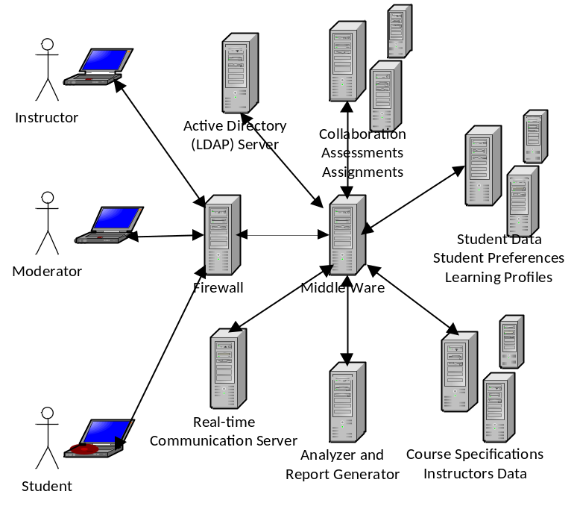
Figure 9: Proposed Adaptive Online Lecture Model IT Architecture

Intelligent Student Tracker Service
For each student, there will be four different learning profiles available:
- General (Education Atlas)
- Felder (Felder and Soloman)
- ATLAS (Conti, 2009)
- Brain Works (Synergistic Learning Incorporated)

General Learning Profile Manager
During registration and profile completion process, the students are asked to complete their general learning preferences features. In case the student selects more than one style, s/he is asked to rank her/his choice, so recommendation can define to what extent it is fulfilling the student’s requirements. General Learning Profile Preferences are: Visual, Auditory, Tactile, Logical, Social and Solitary.

Felder Learning Model
Felder Learning Model can be identified by promoting the student to answer questions that help identifying the student’s learning preferences. Though Felder identifies that the student is middle between different models, Felder model can help the system to identify the student learning features, and prepare the most appropriate learning environment. Felder Learning Model categories are:
- Active and Reflective
- Sensing and Intuitive
- Visual and Verbal
- Sequential and Global

ATLAS Learning Model
ATLAS Learning Model can be identified by promoting the student to answer questions that help identifying the student’s learning preferences. ATLAS learning model categories are:
- Navigator
- Problem Solver
- Engager

Brain Works Learning Model
Brain Works Learning Model can be identified by promoting the student to answer questions that help identifying the student’s learning preferences. Brain Works Learning Model categories are:
- Visual vs. Auditory
- Left vs. Right Brain Hemisphere

Intelligent Cheat Depressor Service
One of the utilized e-Learning activities is “Online Assessments”. Although Online Assessments is not the only criteria to qualify students, it is still an important feature to be activated. One of the problems that prevent us from gaining advantages of Online Assessments is “Leak of Assessments”. Students search the internet for assessments’ questions and answers, and unfortunately they can easily find them. Of course it is the students’ choice to either follow those answers or not. No matter how close you are - as an instructor - to the students, they will not confess “cheating”. Online Assessments are not conducted in a secure and supervised environment.
During analysis of the assessments’ results, some facts became clear to us. One of the results that forced us to analyze assessments’ data was the noticeable number of students who finished the assessment in less than 10 minutes and acquired more than 30 out of 50 as a mark. The assessment consists of 50 True/False questions. Those questions are very well prepared; some of them are accessible via the resources available from the book author(s), and the rest are prepared internally. It was shocking to find that the number of students that got high grades in an almost “not enough time to read the questions” is high. Luckily, students do not know that the system records start-time and end-time, and it can easily calculate duration, or they would have spent longer times just pretending to be solving the assessment.

Problem Domain Analysis
This section holds the analysis results of the online assessment. Figure 10 presents the percentage of students with variant assessment completion times. There are 223 students enrolled in this course with 209 online active users. The number of students who attended the first assessment was 182. Students are classified into 7 groups based on the assessment time as presented in table 4. The strange notice was that almost two third of the students conducted the assessment in less than 20 minutes, and that indicates an alarm.
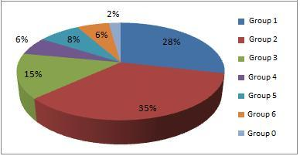
Figure 10: Percentage of Students per Assessment Time
Table 4: Different Students Groups in this Section
Group 0 | Students started but did not complete the assessment and will not be mentioned anymore in this study
Group 1 | Students conducted the assessment in duration less than 10 minutes.
Group 2 | Students conducted the assessment in duration between 10 and 20 minutes.
Group 3 | Students conducted the assessment in duration between 20 and 30 minutes.
Group 4 | Students conducted the assessment in duration between 30 and 40 minutes.
Group 5 | Students conducted the assessment in duration between 40 and 50 minutes.
Group 6 | Students conducted the assessment in duration between 50 and 60 minutes.
To verify the situation, the marks average of each group was calculated and again the results clearly indicate something that is not as “planned to be” situation. Figure 11 depicts the average of the six different groups with the notice that averages are almost the same. That means there are students who solved the assessment in less than 10 minutes with marks close to - and may exceed sometimes - those who solved it in almost an hour.
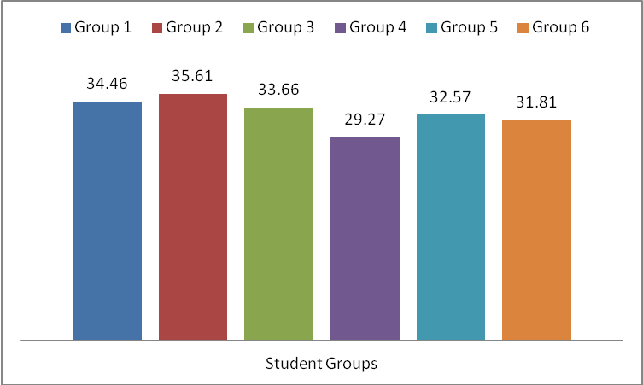
Figure 11: Bar Graph of Marks Average per Different Student Groups
To be sure about the grading issue, further analysis to the results was applied with the result that: Number of students from all groups who scored between 0 and 10 out of 50 is (zero). The number of students from all groups who scored between 10 and 20 is only (one). Figure 12 shows the different counts of different groups for marks between 20 and 30. Figure 13 and figure 14 shows the different number of students with marks between 30 and 40, and 40 and 50 respectively.
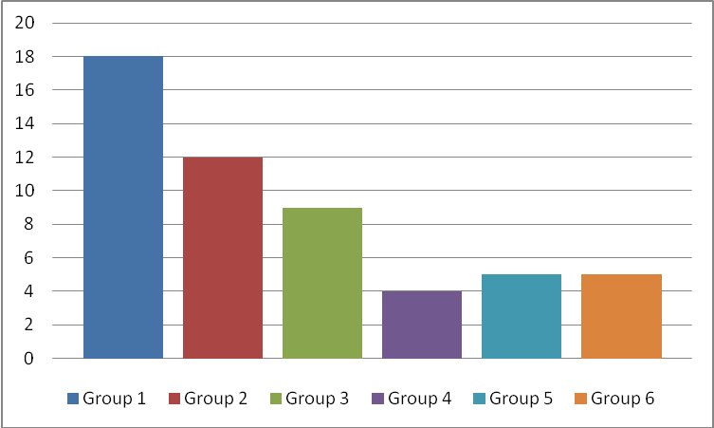
Figure 12: Bar Graph of No. of Students Achieving Grade Range from 20 to 30 Categorized by Group

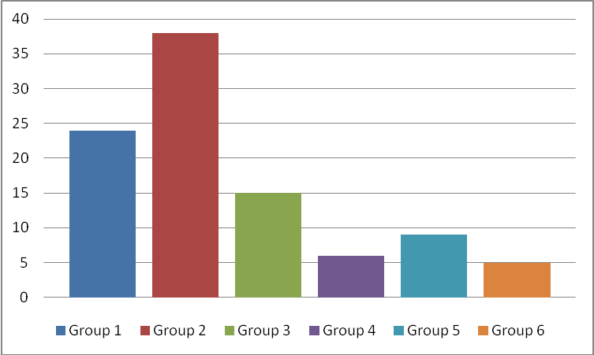
Figure 13: Bar Graph of No. of Students Achieving Grade Range from 30 to 40 Categorized by Group
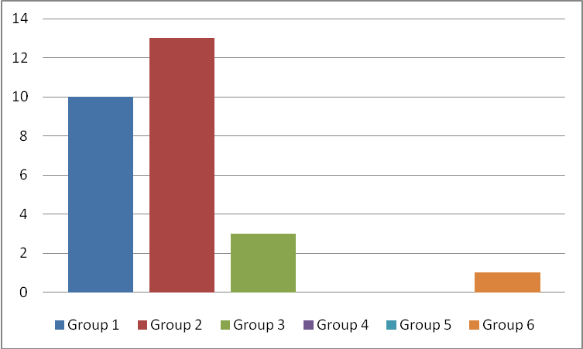
Figure 14: Bar Graph of No. of Students Achieving Grade Range from 40 to 50 Categorized by Group

Comments on Results
Here are some cheating tips that have been witnessed during students’ monitoring and feedback:
- Access to Answers’ Files: Open the assessment PDF or document file, search for keywords, and immediately apply answers. Most students have high memorable capabilities regarding mapping questions and answers.
- Collaborative Solution: Though collaboration is really important in the learning process, this way of collaboration to cheat was really new. More than one student conducts the assessment. One holds the laptop, others hold different pages of the assessment answers, so they optimize the search time, and the one holding the laptop says the question loudly and of course students can find answers in no time. Of course in Non-Supervised e-Learning environment, there is no way to guarantee that students themselves attended the assessment.
Two categories of students must not be neglected to assure certain learning quality level:
- Careless Students: They do not really need to read the assessment questions. They only pick an answer and they don’t care about the results. There are students who answered 50 questions in less than 3 minutes, which gives them an average reading of 3.6 seconds for each question. Another form of carelessness was presented in the 4 students (out of 182 that is almost 2%) who did not finalize the assessment though they started it.
- Not Interested Students: Almost 23% of the course enrolled students (41 students out of total 223 students) did not attend any of the e-Learning activities. This percentage is huge, and in our course, it is not acceptable at all. However, motivating students to attend Learning activities is always a challenge.

Proposed Solution
Based on results presented in the aforesaid section, it is clear that there are issues that shall be considered before providing students with online exams. There must be a stronger way of controlling the Exam process in order to make marks more trustable. Proposed Solution tips to this issue are many. More studies about efficiency and effectiveness of each one need to be conducted and further analyzed and studied. Those actions can be categorized into two categories: Educational and Technical solutions. The solution include Pedagogical and Technical aspects.

Pedagogical Proposed Solution Aspects
Educational Solutions include the attempt to present an unlimited Assessment Items Repository, and to track the students’ progress during the learning process, so peaks can be determined and be a mark for inappropriate activity during the learning process. Also, a timed question is almost a must in the exam process. Timer shall not only start after the student sees the question, we are thinking about calculating time for both displaying and solving the question. Therefore, theoretically, students shall never find time to cheat. This study proposes some tips that can be used as solutions that focus on four aspects of the online assessment process and can be thought of as the integration of the all:
- Questions Based Solution: Assessments banks should consist of larger number of questions with the chance to have 1/4 or 1/3 the assessment different from one student than the other. Also, instructors should work on updating assessments banks and keeping them out of reach for students.
- Environment Based Solution: This solution is complimentary to the previous suggested one. Supervised e-Learning environments are important, and simply are the only way to guarantee certain accepted level of learning quality. Students can find the time to search the answer files because they can access them easily. Hopefully when students do not have access to such files, they might learn better.
- Assessment Based Solution: Timer that forces students to read questions before viewing the answers might be a good idea. Maybe by forcing students to wait for answers before selecting one of them will be a catalyst for the student to read the questions and all the answers. Though this is not a guarantee, but it might be a good way to do so.
- Student Based Solution: It is important to discuss with students the importance of e-Learning activities in the learning process, and the gains they can easily acquire and make use of via utilizing such activities. The attempt to qualify students’ culture with e-Learning is important to start gaining e-Learning advantages. Yet, not all students believe in e-Learning; only 182 out of 223 cared about attending the online course activities. The rest needs to be talked to instead of neglecting them.
Most students do their best to play it smart, even if they will not follow the rules. Solutions to guarantee learning efficiency and effectiveness for current situations must be thought of about regularly. Unfortunately, students usually advance instructors in utilizing technology for their purposes, which might be “cheating”. We - as instructors - need to evaluate the situation regularly and rely more on student performance analysis tools to find out the unclear facts.

Technical Aspects of the Solution
Technical Solutions are a real challenge. There is no Web based assessment system that presented a clear solution to such a problem. The solution lies in a well-controlled desktop application that must be used in the Exam process. Desktop applications provide techniques that are not available via Web based systems. Those techniques include:
- Keyboard Hooking: The desktop application can control keyboard strikes on system basis and not on application basis. So, we can control which keys are available for students to click and which are not. However, such solution is applicable for Microsoft Windows based Desktop Applications only, as Java Virtual Machine (JVM) does not provide such control over the Operating System, and that will stop authors from developing a platform independent Exam Desktop Application.
- Operating System Log File: The desktop application can check the Operating System Log file, and when it finds that the student executed any of the non-authored applications during the exam, it exits the exam. However, students can be smart enough to use two computers during the exam: one for taking the exam, and another for cheating. Besides, checking the Log file will be a time based process that is not guaranteed to take place anytime.
- Check Running Processes: The desktop application will check the running processes on the system before and during the exam, and will exit any non-exam required process that is running during the exam. This technique seems to be the most appropriate technique, however, building this list of processes will take time and effort.
By combining the above mentioned techniques - both educational and technical - we might get better circumstances during exams, and hopefully results will be available soon “after applying the exam to students, recording and analyzing statistics”.

Student Intelligent Services
Student Intelligent Services are: Intelligent LOs Recommender, Intelligent Agenda Study Time Planner and Intelligent Meeting Manager for Suspended Students.

Intelligent LOs Recommender
Recommender system in an e-Learning context is a software agent that tries to “intelligently” recommend actions to a learner based on the actions of the previous learners. Recommendation could be an online activity such as doing an exercise, reading posted messages on a conferencing system, or running an Online– simulation. Or it could be simply a web resource (Zaiane, 2002).Table 5 presents intelligent LOs Recommender Service specifications, and figure 15 presents its detailed flowchart.
Proposed Intelligent LOs Recommender processes data in two phases: phase 1 where Intelligent LOs Recommender actually recommends LOs list based on student preferences and LOs coverage for topics. The instructor approves the recommended list, and when modifications are needed, the instructor updates weights causing the list to be generated, not the list itself. This way, instructors would enhance the system. Phase 2 includes reordering the generated recommended list based on students’ preferences. Users like to find their preferred material directly, and this phase is responsible for achieving this objective.
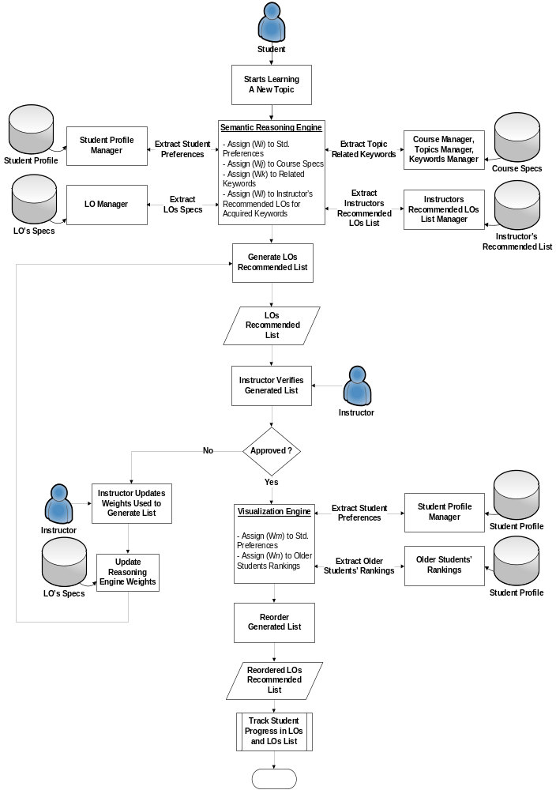
Figure 15: Intelligent LOs Recommender Flowchart

Table 5: Intelligent LOs Recommender (Phase 1) Specifications
Input
Student Preferences | Proposed Model stores different learning preferences that identify the student learning behavior. Those preferences are considered to identify different study plans.
Related LOs Specifications | LOs satisfy students’ classes by percentage. The higher LOs available that matches students’ preferences, the higher this topic is recommended for teaching.
Learning Topics Data | Extract Topics related Keywords to match LOs with topics.
Instructors Recommended LOs list | Previous instructors’ recommended LOs list for certain topics. In the beginning, instructors will need to approve generated lists every time to fine tune the system, then a database of approved lists will be used for approval. Instructor’s approval will be required from time to time.
Processing
By assigning different Weights to the different inputs, intelligent methods can be used to generate a weighted list summary report.
Output
LOs Recommended List | If this is the first time for the system to generate this list, the instructor’s approval is needed. Otherwise, the system compares this list to previously stored lists. Matching percentage less than 100% is allowed for systems adaptation.
Figure 16 depicts one of the Intelligent LOs Recommender Service implementation scenarios. This scenario uses different technologies and techniques presented by Riad, El-Minir, Sabbeh (2008). Modifications to the previous recommender were required to fit the new recommendation scenario.
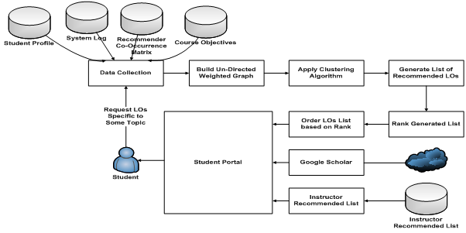
Figure 16: LO's Recommender as a Service Process
Figure 16 presents an overview of LOs Recommender as a Service recommendation process. The student, the main initiative of the learning process, asks for suitable LOs that fit the learning objectives of the course topics. S/he finally gets three different lists of LOs: Ranked LOs list, list of LOs from Google Scholar and an Instructor Recommended list.
The Student request can be identified either implicitly through LOs Recommender as a Service observation of students’ navigation through learning topics or explicitly through an ordinary search using Proposed Adaptive System Web site’s interface. On receiving a new request, LOs Recommender as a Service generates a set of recommendations, a list of ranked suggested LOs to view based on content similarity with the student request, and results from Google Scholar.
At each request, LOs Recommender as a Service identifies the requested LO, Session ID, Student ID and Referrer LO, that is the LO which the student was viewing prior to the requested one. Based on students’ access behavior, Recommender as a Service updates the underlying Co-Occurrence Matrix as depicted in figure 17.
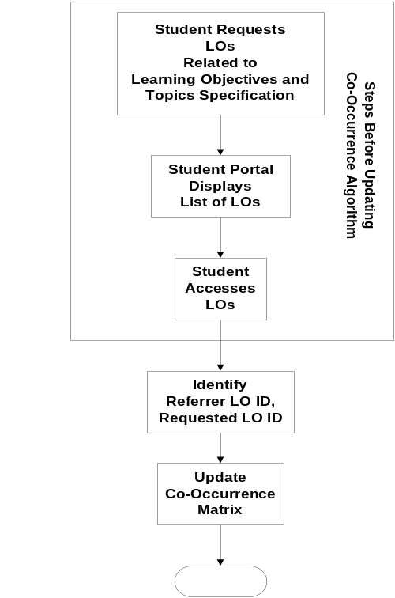
Figure 17: Update Co-Occurrence Matrix Steps
Co-Occurrence Matrix is the mind of the Proposed LOs Recommender as a Service, and it is reactive because it reflects the students’ access to Los, as it updates weight between LOs based on students’ navigation model between LOs. Co-Occurrence Matrix is a Matrix
M = N * N
Where
N = No. of LOs in LCMS
Each element in the Co-Occurrence Matrix presents a Weight W(u, v). The equation used to update Co-Occurrence Matrix values is
W(u,v) = N(u,v) / Max (Nu,Nv)
Where
W(u,v) = Weight of adjacent LOs (u,v)
N(u,v) = Number of Students’ Sessions in which both LO(u) and LO(v) are visited
N(u) = Number of Sessions in which LO(u) is visited
N(v) = Number of Sessions in which LO(v) is visited
LOs Recommender as a Service relies on a Co-Occurrence Matrix that is stored in the database between different LOs. Building this Co-Occurrence Matrix is a student reactive process, because it is mainly based on student navigation model between LOs. LOs Recommender as a Service gathers data required to recommend LOs to students from different data sources, and then builds Un-Directed Weighted Graph between the appropriate LOs based on the stored Co-Occurrence Matrix. The Clustering Algorithm is applied to this Un-Directed Weighted Graph to define different clusters and generate the Recommended List of LOs. This list is then ranked based on the Ranking Algorithm and returned to the user.
- Building Un-Directed Weighted Graph
The Un-Directed Weighted Graph is built programmatically based on the equation:
G = (V, E)
Where
V = Set of Vertices; that contains LOs Identifiers
E = Set of Weighted Edges between Vertices
An example of the Un-Directed Weighted Graph between LOs is the one presented in figure 18. Un-Directed Weighted Graph does not highlight the order of viewing Los, because this ordering will complicate the Clustering process.
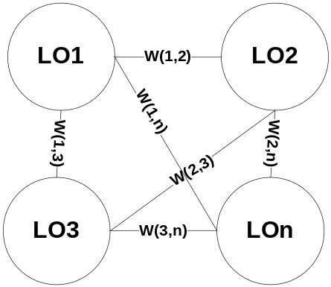
Figure 18: Example of Un-Directed Weighted Graph between LOs
2. Applying Clustering Algorithm
LOs Recommender as a Service finds clusters based on Usage Data Analysis by partitioning the built Un-Directed Graph to its Connected Components, assigning each component that would be an LO into a different cluster based on a threshold value used to exclude poor correlated edges.
The List of Recommended LOs contains LOs that coexist within the same cluster of the LOs of the requested learning topics. Utilized clustering algorithm is Depth First Search (DFS). DFS is an algorithm for traversing or searching a tree, tree structure or graph. It is used to find graph’s connected components. Threshold value shall be used to eliminate poor correlated edges. A start value of 0.4 is used in the beginning and it is a matter of change for later uses based on LOs Recommender performance. Figure 19 presents an implementation of DFS algorithm.
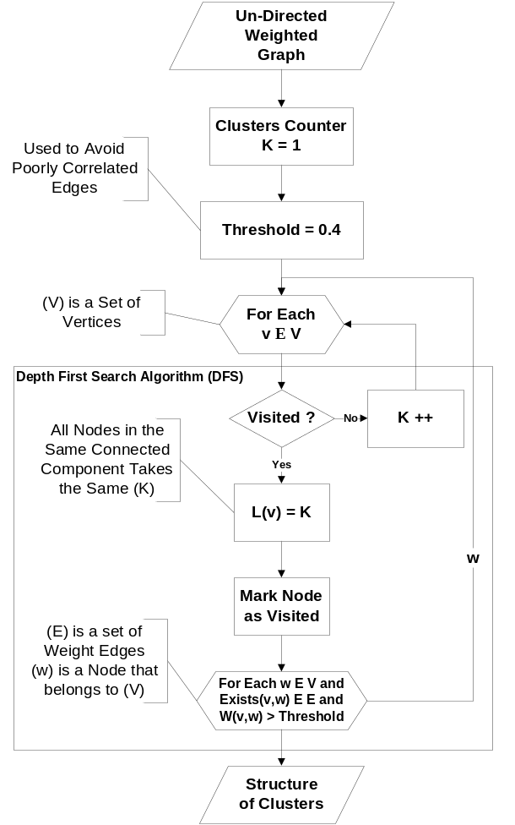
Figure 19: Flow Chart of Implemented Depth First Search Algorithm
3. Applying Ranking Algorithm
The proposed Recommender as a Service uses a Content based Ranking Algorithm for ranking Los, that is Term Frequency – Inverse Document Frequency (TF – IDF). TF – IDF is calculated as follows:
- Calculate Term Frequency (TF): TF is the measure of how often a Term_{i} is found in a particular LOj. Each term in the input string is compared with each LO’s Meta-Data and Content if applicable.
TFi,j = Frequency of Termi in LOj / No. of Words in LOj
- Calculate Inverse Document Frequency (IDF): The number of LOs in which the term occurs divides the total number of LOs in the database, resulting in R. The Log of R gives the IDF. IDF is calculated based on this formula
IDFi,j = Log (No_d / No_LOs_Containing Termi)
Where,
No_d is the total No. of Retrieved LOs
No_LOs_Containing Term = No. of Relative LOs that contain Termi
- Calculate the Weight of Termi in Each LO: The weight of the Termi is calculated indicating the importance of the query term in each document. The higher the weight of a term in a document, the more important is that document.
Weighti,j = TFi,j * IDFi,j

Table 6: Intelligent LOs Recommender (Phase 1) Specifications
Input
Student Preferences | Proposed Model stores different learning preferences that identify student learning behavior. Those preferences are considered for identifying different study plans.
Related LOs Specifications | LOs satisfy students’ classes by percentage. The higher LOs available that matches students’ preferences, the higher recommended this topic for teaching.
Learning Topics Data | Extract Topics related Keywords to match LOs with topics.
Instructors Recommended LOs list | Previous instructors’ recommended LOs list for certain topics. In the beginning, instructors will need to approve generated lists every time to fine tune the system, then a database of approved lists will be used for approval. Instructor’s approval will be required from time to time.
Processing
By assigning different Weights to the different inputs, intelligent methods can be used to generate a weighted list summary report.
Output
LOs Recommended List | If this is the first time for the system to generate this list, Instructor’s approval is needed. Otherwise, the system compares this list to previously stored lists. Matching percent less than 100% is allowed for systems adaptation.

Intelligent Agenda Study Time Planner
Intelligent Agenda Study Time Planner helps students identify their study times, and controlling interruptions (e.g. web browsing, phone calls, having drinks and others) in order to improve their performance. Because tracking students’ habits is important, students need to be honest and record their different activities within the pre-defined timetable to help the system identify shortages in study time tables, and help them improve their study habits.
Summary reports are available for students to identify major types of interruptions that affect their study, and advise them about changing their habits. Table 7 presents the Intelligent Agenda Study Time Planner specifications, and figure 20 presents detailed flowchart. General agenda for different activities that is customized for each student based on their preferences. Students who prefer football are encouraged to participate in football games, and the same for other activities.
Table 7: Intelligent Agenda Study Time Planner Specifications
Input
Student Preferences | Proposed Model stores different learning preferences that identify student learning behavior. Those preferences are considered for identifying different study plans.
Related LOs Specifications | LOs satisfy students’ classes by percentage. The higher LOs available that matches students’ preferences, the higher recommended this topic for teaching.
Processing
By assigning different Weights to the different inputs, intelligent methods can be used to generate a weighted list summary report.
Output
Personalized Agenda | Personalized agenda for each student that help her/him organize their time between different activities and study.

Intelligent Meeting Manager for Suspended Students
Suspended students must meet one of the instructors to help them identify and work on solving their challenges. Table 8 presents the specifications of Intelligent Meeting Manager for Suspended Students, and figure 21 depicts its detailed flowchart.
Table 8: Intelligent Meeting Manager for Suspended Students Specifications
Input
Student Timetable | Proposed Model extracts suitable students’ meeting times.
Instructors to Meet | Different instructors can support the same course. Students are able to give priorities for different instructors.
Processing
By finding matches between student’s available time and instructors available time, proposed meeting times are presented. Three different proposed meeting times are presented, and waiting for instructor’s approval in order.
Output
Proposed Meeting Time | Proposed Meeting is approved by instructor. If approved, student is informed with this meeting and now the instructor has full control on student’s status. Instructor can reactivate student, make her/him access LOs, and attend exams if needed.

Conclusion
This paper presents different intelligent features to improve students’ habits and their performance through e-Learning process. This goal can be achieved by applying different technologies available to educational institutions, instructors and students in an innovative way to provide deeper communication between instructors and students. Services’ specifications and IT-Infrastructure architecture required to enable the proposed framework were presented, highlighting the different challenges and their solutions.
The General Services category includes the Intelligent Learning Object (LO) Classifier service. The Instructor Intelligent Services are: Intelligent Time-to-Learn Topic Calculator, Intelligent Study Plan Advisor, Intelligent Online Lecture LOs Advisor, Intelligent Student Performance Tracker and Intelligent Cheating Depressor. The Student Intelligent Services are: Intelligent Agenda Study Time Planner, Intelligent Meeting Manager for Suspended Students and Intelligent LOs Recommender.
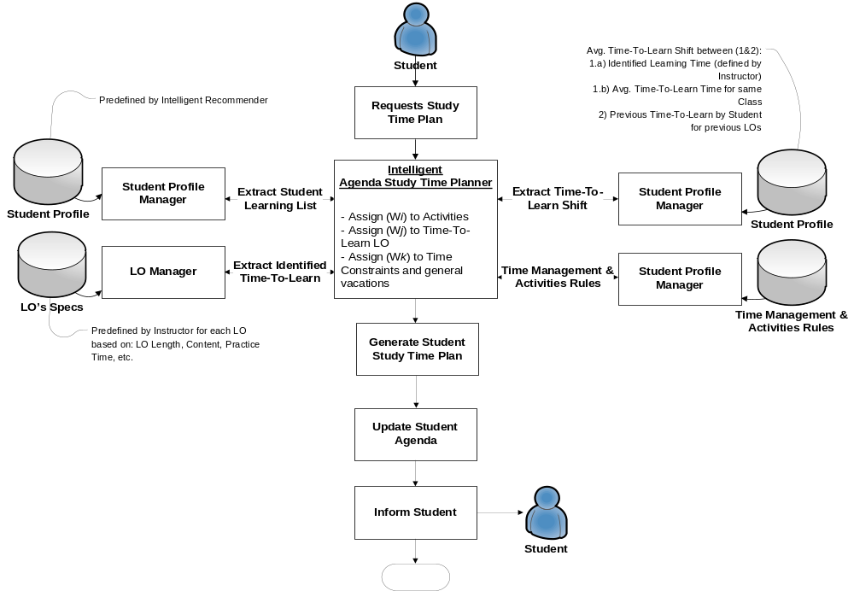
Figure 20: Intelligent Agenda Study Time Planner
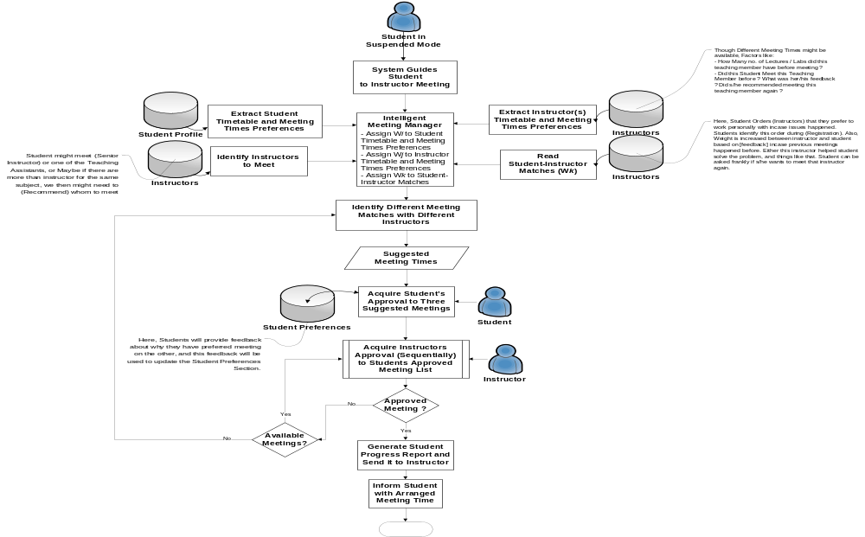
Figure 20: Intelligent Meeting Manager for Suspended Students Flowchart

References
ADL Press Release: Advanced Distributed Learning. Retrieved on May 10, 2010 from http://www.adlnet.gov/adlnews/Documents/News%20Archive/SCORM20044thEditionAnnounced.aspx
A. M. Riad, Hamdy K. El-Minir, Haitham A. El-Ghareeb (2010). “Adaptive e-Learning Model as a Solution for Current e-Learning Challenges”, Journal of the American Society for Information Science and Technology, Wiley, Under Review.
A. M. Riad, H. K. Elminir and S. F. Sabbeh, "Recommender System for E-Research ", Mansoura Engineering Journal “MEJ”, Vol. 33, No. 1, March 2008.
Education Atlas. Identifying your learning style. Retrieved June 12, 2010 from http://www.educationatlas.com/student-learning-styles.html
Gary J. Conti (2009). “Development of a User-Friendly Instrument for Identifying the Learning Strategy Preferences of Adults”. Teaching and Teacher Education, Elsevier.
J. Zhang, D.-K. Kang, A. Silvescu and V. Honavar, "Learning Accurate and Concise Naive Bayes Classifiers from Attribute Value Taxonomies and Data", Knowledge and Information Systems, 9(2), March 2006.
MOLE - Text Analysis Group (1999). Retreived on May 10, 2010 from http://isp.imm.dtu.dk/thor/projects/multimedia/textmining/node11.html
Osmar R. Zaiane, “Building a Recommender Agent for e-Learning Systems”, Proceedings of the International Conference on Computers in Education (ICCE’02), IEEE 2002
Rosen, A. (2009). e-Learning 2.0: Proven Practices and Emerging Technologies to Achieve Real Results. AMACOM.
Richard M. Felder, Barbara A. Soloman. “Learning Styles and Strategies”. Retrieved 12 June 2010 from http://www4.ncsu.edu/unity/lockers/users/f/felder/public/ILSdir/styles.htm

Synergistic Learning Incorporated. Retrieved 12 June 2010 from http://ilearn.senecac.on.ca/techwrite/testing.html

